1. Open **Google Chrome**
2. Go to <https://accounts.google.com/> and login using the followingcredentials:

username: <Username>

password: <Password>

1. Now go to https://remotedesktop/google.com  
   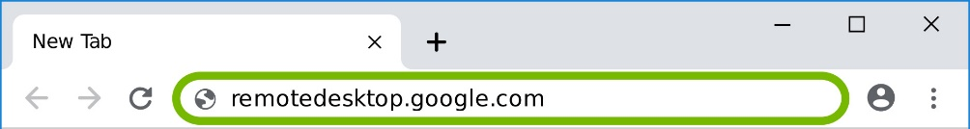
2. Select **Remote Access** at the top, then select the **download button** for Set up remote access.  
   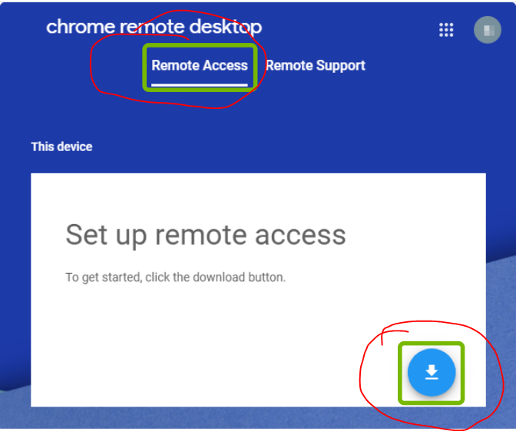
3. A new window will open showing the Chrome Remote Desktop Extension. Select **Add to Chrome**.  
   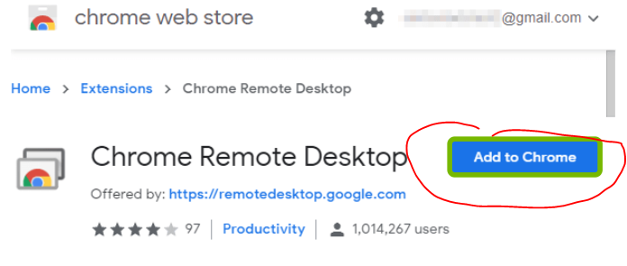
4. Select **Add Extension** at the bottom.  
   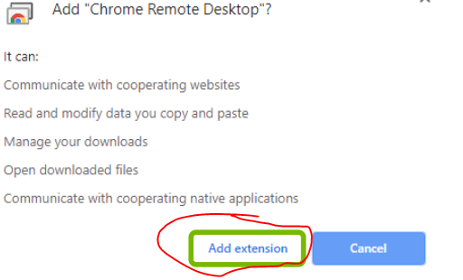
5. Chrome will download a program to install, and will ask if you want to install it. Select **Yes**.  
   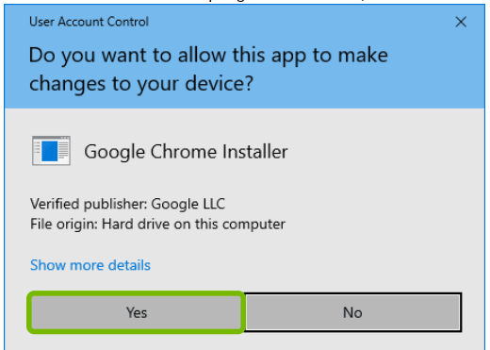
6. If the computer ask you for administrative permission, please on “Yes”
7. Select **Turn On** for Set up remote access.  
   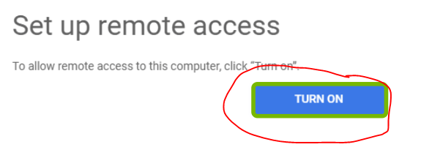
8. In the box named “Enter a name for your computer” type Judith, then select **Next**.  
   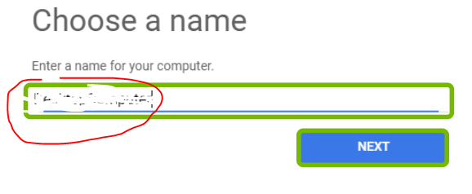
9. In the 2 boxes **enter the following number**, then select **Start**.

XXXX  
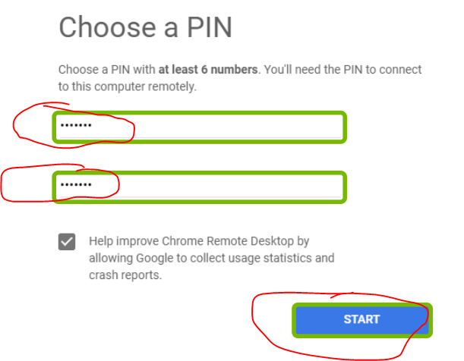

1. Chrome Remote Desktop will enable, and request permission. Select **Yes**.  
   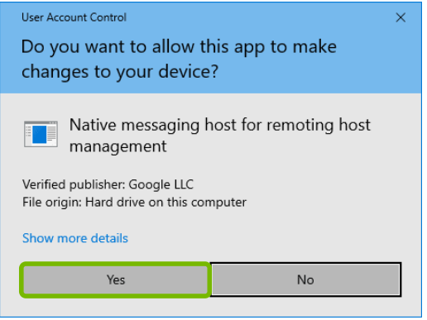
2. Chrome Remote Desktop is now setup